**Level I**

**Basic Pytorch Knowledge**

**Tech : Pytorch, Tensorflow**

**Dataset: (Any data set)**

1. Check cuda is enabled in the system or not?
2. List all the necessary NLP Library ?
3. create vocabulary ?
4. create word2vec embeddings?
5. Create a t-sne word2vec cluster?
6. State difference between tf idf and one hot encodings?
7. Explain How you will create the NLP Pipeline ?
8. Perform Gpu Inferencing and Cpu Inferencing? Hint ( [use colab](https://colab.research.google.com/))
9. Compare results of bidirectional Lstm and Rnn?
10. State Architecture of RNN?

**Level II**

**Data Set Link: (Take Any Dataset but avoid using benchmark data)**

**Perform Below Listed Preprocessing Task in proper order as per your dataset using torch or tensorflow.**

**Preprocessing / Feature Engineering Pipeline**

1. Emoji Removal
2. Lemmatization
3. Stemming
4. Word Tokenization
5. Grammar Correction
6. Http Links Removal
7. Stop Words Removal
8. Sentence Tokenization
9. Lower casing
10. Remove white spaces
11. Text Normalization
12. Part of speech tagging

**Level III**

**Dataset Link: (Take Any Dataset but avoid using benchmark data)**

**Tech : Pytorch, Tensorflow**

* **Take any Dataset and perform any one task. (You are free to choose Tasks as per your understanding)**
* **Tasks: Sentiment Analysis , Text Classification , Text Generation, Machine Translation, Text Summarization , Question Answering.**

**Implementation**

**Question 1**

**Implement Encoder decoder architecture and train on any dataset as per your choice.**

**Tech : Pytorch, Tensorflow**

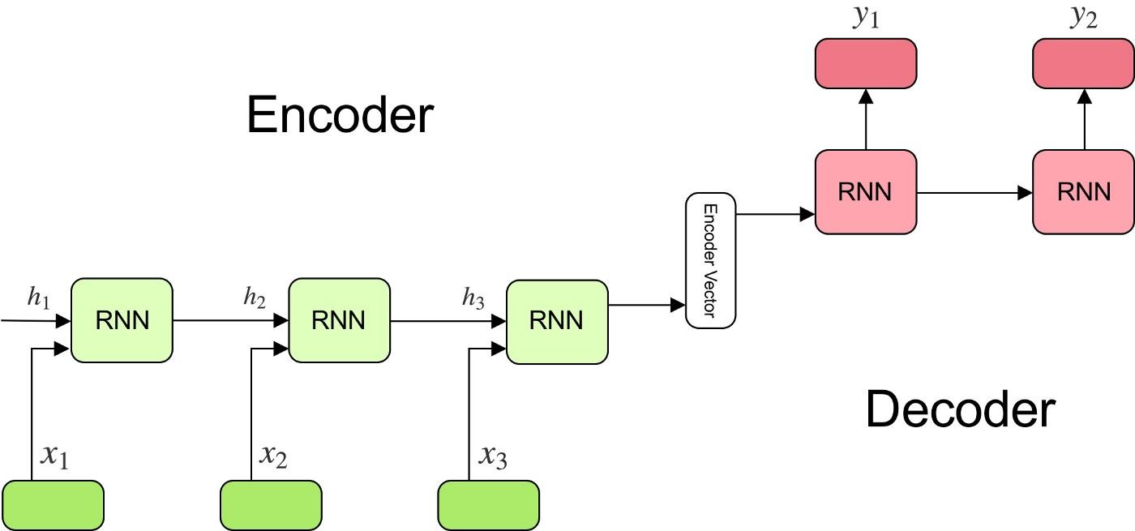

**Question 2**

**Tech : Python**

**Implementation of NLP Metrics. (Avoid using any nlp library)**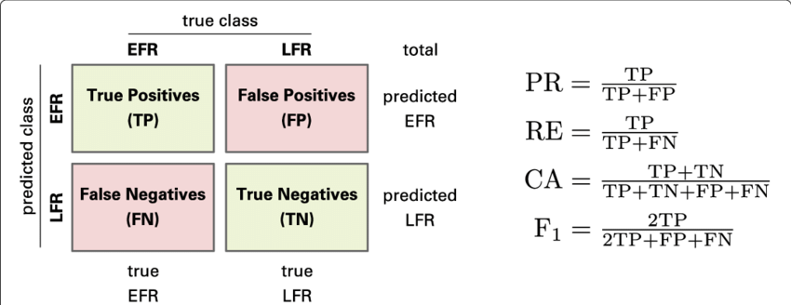

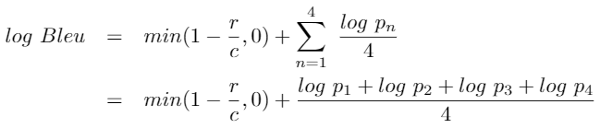

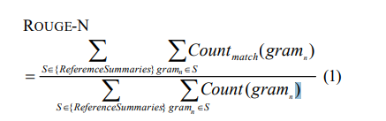

1. **Bleu Score**
2. **Rouge Score**
3. **Meteor**
4. **Classification Metrics**
5. **Precision , Recall and F1 Score**

**Question 3**

**Implement Chatbot using a hugging face library.**

**Tech : Transformers**

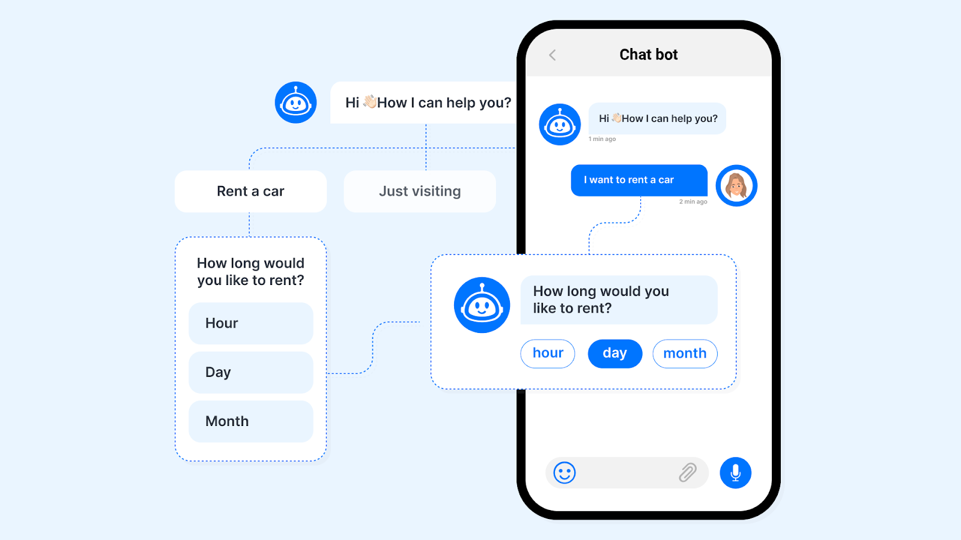

**Question 4**

**Implement Reverse Image Search Engine.**

**Tech : pytorch**



**Question 5**

**Implement Resume Parser using Bert.**

**Tech : pytorch**

